Sprint 3 - Agility Design Document

November 30, 2022

Table of Contents
1. Executive Summary 3
1.1 Project Overview 3
1.2 Purpose and Scope of this Specification 3
2. Product/Service Description 3
2.1 Product Context 3
2.2 User Characteristics 3
2.3 Assumptions 3
2.4 Constraints 3
2.5 Dependencies 4
3. Requirements 4
3.1 Functional Requirements 5
3.2 Security 5
3.2.1 Protection 5
3.2.2 Authorization and Authentication 6
3.3 Portability 6
4. Requirements Confirmation/Stakeholder sign-off 6
5. System Design 6
5.1 Algorithm 6
5.2 System Flow 6
5.3 Software 6
5.4 Hardware 6
5.5 Test Plan 7
5.6 Task List/Gantt Chart 7
5.7 Staffing Plan 7

Executive Summary

Project Overview
The third project, sprint 3, agility design. The robot Sphero will run the obstacle course. The course will start in a square. Then the robot will encounter 3 objects (3 bottles) which it must avoid. Next, the robot will go over the ramp. Finally, the robot will knock over as many pins as possible. Points added for each obstacle the robot completes, for each obstacle avoided and, for each pin the robot topples.

Purpose and Scope of this Specification
The goal is for the Sphero robot to follow its path correctly avoiding the obstacles
In scope
This document addresses the processes and requirements to carry out the endurance project:
- Modifications in the process so that the robot complies with its trajectory.
Out of Scope
- Having the robot follow the blue tape exactly, rather than just being within an inch or two from the tape while traveling around the course.

Product/Service Description
The factors that can affect the product and its requirements are that if for example there is an object in the path of the robot, such as a table, a wall, a chair, a person, etc., because it cannot advance in the desired direction. In this sprint, there are different obstacles, such as not touching the bottles, going through the ramp (the binder), and knocking down the largest number of pins. In addition, if the floor is sloping, it deflects the robot a bit. Also, if the floor is smooth, it will make it slide a little more, but in this case the result will be very similar to what is desired.

Product Context
The product relates to other products, this means that the robot Sphero is related to other robots, because Sphero is a robot that is controlled remotely. It is self-contained because it contains in itself everything necessary to work. It interfaces with a variety of related systems.

User Characteristics
Professor Gil Eckert from Monmouth University, master from Kean University and bachelor of science from Stockton State College. He has a lot of knowledge in computer science and software engineering, with a certified network engineer. He did research in simulation, data analysis and manipulation, algorithmic development, and quality control.

Assumptions
Although we are not experts in programming Sphero, with what Professor Gil taught us, as a group we have the necessary skills to do the programming. After doing the first two sprints, we feel that we are gaining more experience as we program more. In addition, it is important to have room HH208 available to be sure that the robot makes its way as it should.

Constraints
Constrain the design options, including
- Connecting to another robot or executing another programming affects the route that you want to give the robot.
- Access, management and security
- System resource constraints: limits on disk space, obstacles in the way of the robot).

Dependencies
This new product required programming. For the programming, it is required to have the robot Sphero and the space (the room HH208).

Requirements

Functional Requirements
Req# | Requirement | Comments | Priority | Date Rvwd | SME Reviewed / Approved
AGIL_01 | Start robot in the square | Points will be deducted if not met | 1 | 11/30/22 | Approved
AGIL_02 | Robot will turn right 90 degrees after first obstacle | Points will be deducted if not met | 1 | 11/30/22 | Approved
AGIL_03 | Robot will turn left 90 degrees after second obstacle | Points will be deducted if not met | 1 | 11/30/22 | Approved
AGIL_04 | Robot will turn right 90 degrees after third obstacle | Points will be deducted if not met | 1 | 11/30/22 | Approved
AGIL_05 | When robot makes it over jump, it will right towards the pins. | Points will be deducted if not met | 1 | 11/30/22 | Approved
AGIL_06 | Robot will run into pins and knock them over. | Points will be determined by how many pins are knocked over | 2 | 11/30/22 | Approved

Security
Take care of your privacy, do not tell other people your login information to Sphero or GitHub. Also, take care of your robot, keep it away from dangerous environments.

Protection
You are the one who controls your app and your programming. After downloading the Sphero app, you can log in in two ways, school and home. When you enter the school part, three different options appear. The first is student, where it asks you for a code to join your class and share your program with them. The second is the teachers, where it allows you to create a class and manage it, this way the professor will be able to know the process that the students have. The third is to skip the sign in part and start programming immediately, these users have the possibility to sign in whenever they want. On the other hand, there is a home, where you can enter through your email or also sign in with apple.

Authorization and Authentication
Specify the Authorization and Authentication factors. Consider using standard tools such as Pub Cookie.

Portability
Portability is the ability of software to be transferred from one machine or system to another. In this case, after programming from the cell phone or the computer, we need to pass the information to the Sphero robot so that this can work. For example,
- Use of a proven portable language;
- Use of a particular operating system. Sphero and GitHub;
- The need for environment-independence - the product must operate the same regardless of operating systems, networks, development or production environments.

Requirements Confirmation/Stakeholder sign-off
Meeting Date | Attendees (name and role) | Comments
11/30/22 | Michael, Sophia | Confirmed all

System Design
This section will provide all details concerning the technical design, staffing, coding, and testing the system

Algorithm
- Start robot in the square.
- Robot will turn right 90 degrees after first obstacle.
- Robot will turn left 90 degrees after second obstacle.
- Robot will turn right 90 degrees after third obstacle.
- When robot makes it over jump, it will right towards the pins.
- Robot will run into pins and knock them over.

System Flow
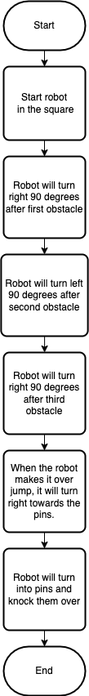

Software
The software used to develop and deploy this application is the block code on the Sphero app or website.
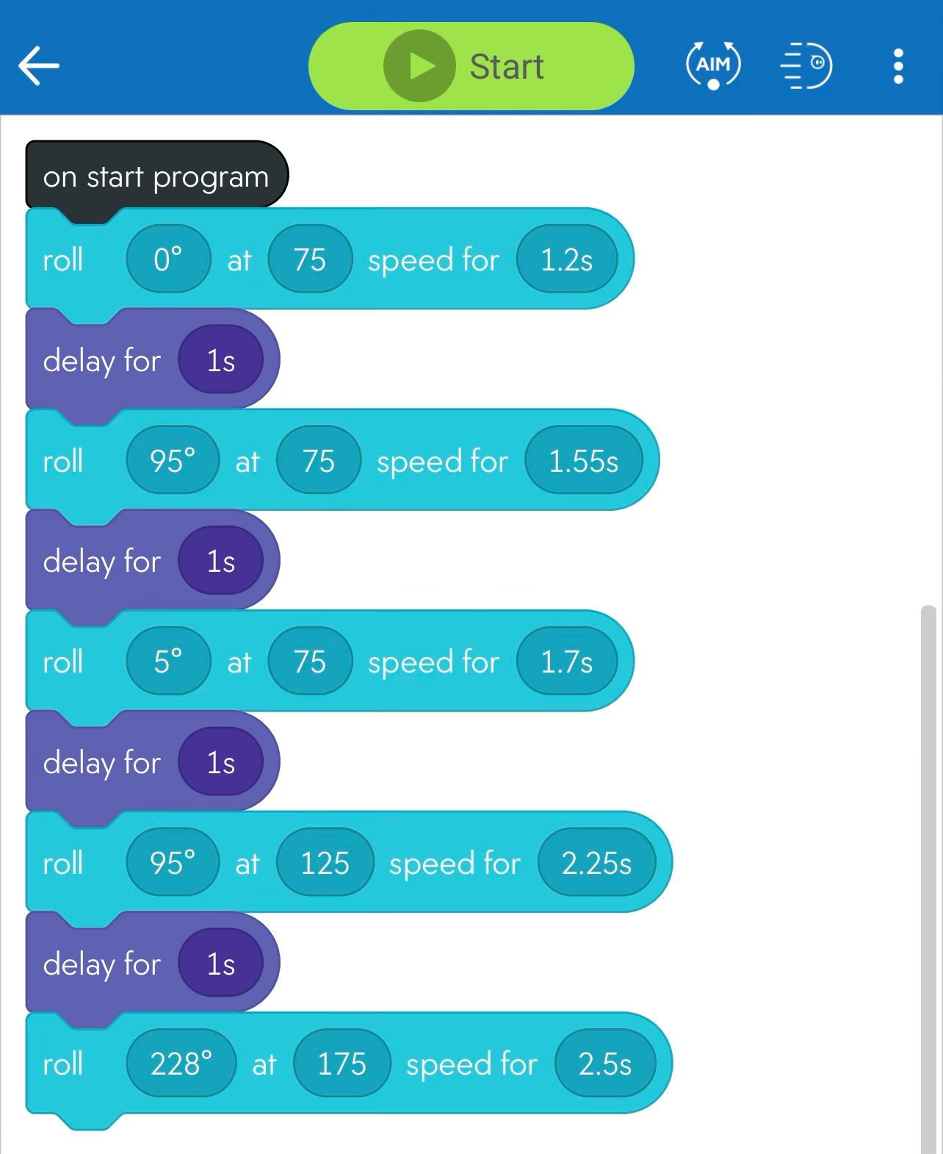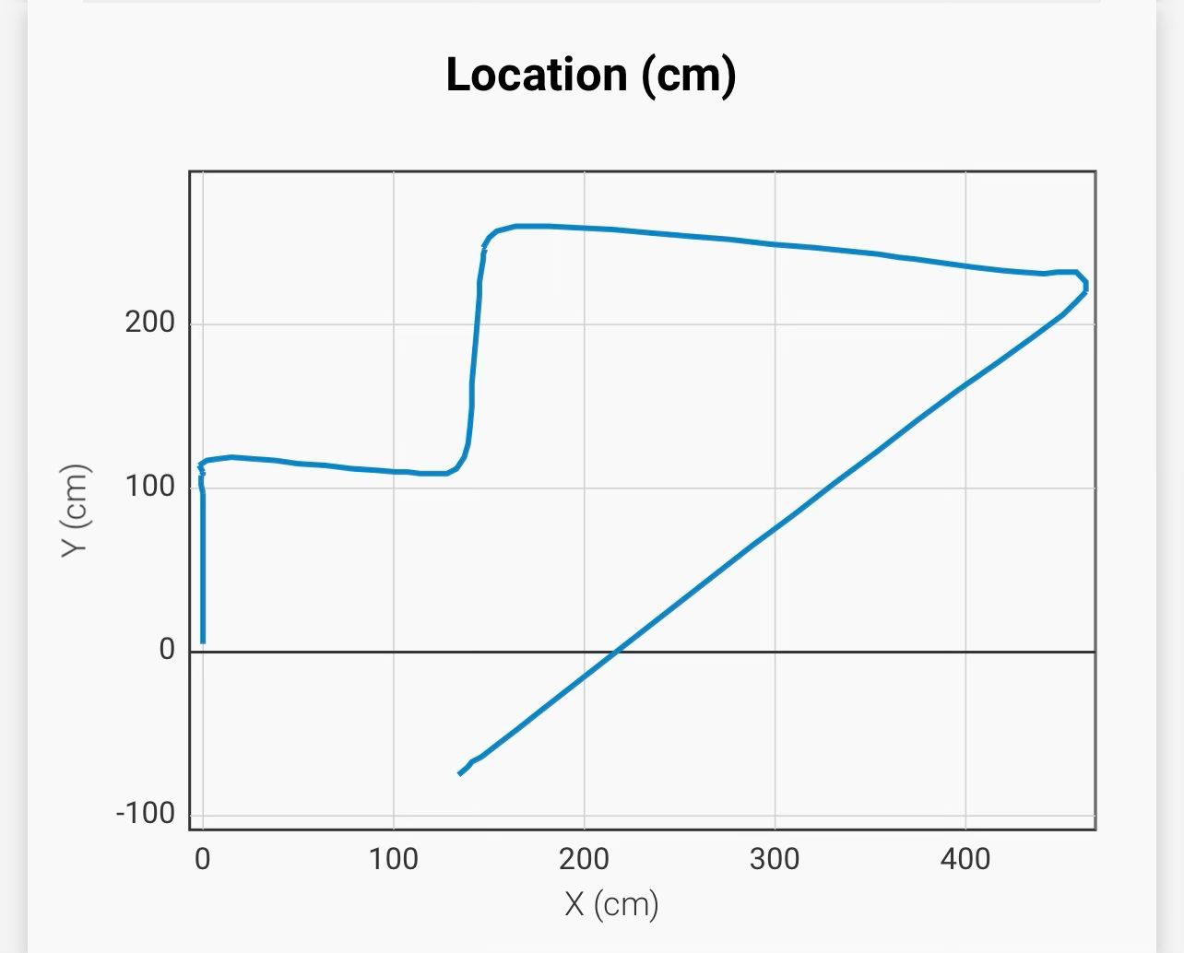

Hardware
The hardware platforms that were used to develop, test and demonstrate this application were macOS, Microsoft Windows, and IOS.

Test Plan

Reason for Test Case | Test Date | Expected Output | Observed Output | Staff Name | Pass/Fail
Pass the first obstacle | 11/30/22 | Go straight and then turn to the right | Turned too late and went of course | Michael, Sophia | Fail
Pass the first two obstacles | 11/30/22 | Go straight, turn right, and then turn left without touching the bottles | Made the first two turns without touching any obstacles | Michael, Sophia | Pass
Pass the third obstacles and make it over binder | 11/30/22 | Make the first three turns and jump without hitting the bottles | Made it past the turns but went to the left of the jump | Michael, Sophia | Fail
Start at third turn to see if the robot can make the jump and the last turn | 11/30/22 | Hit the pins at the end while also making the jump | Made the jump but went to the left of the pins | Michael, Sophia | Fail
Get past all the turns, jump, and hit the pins | 11/30/22 | Complete the course without hitting any obstacles and hitting all the pins | Made all the turns and jump but only hit one pin | Michael, Sophia | Pass
Follow the course and hit all the pins | 11/30/22 | Complete the course without hitting any obstacles and hitting all the pins | Hit the second obstacle when turning | Michael, Sophia | Fail
Finish the course by not hitting any bottles and knocking down all pins | 11/30/22 | Knock all pins down and avoiding all of the obstacles | The robot made it around the whole course without hitting any bottles and knocking down all pins | Michael, Sophia | Pass

Task List/Gantt Chart
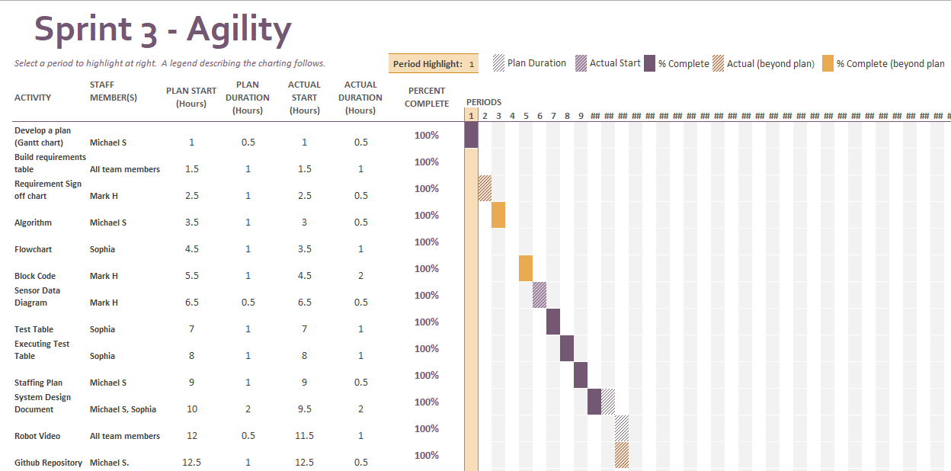

Staffing Plan

Name | Role | Responsibility
Sophia | SDD creator/editor | Create and edit the System Design Document
Michael | GitHub Owner | Control the GitHub repository
Mark | Programmer | Create the block cod and test it

